Kempe-Based 5-Colour-Theorem Colouring Program:

A program (Program) that 5-colors any simple, planar uncoloured graph if the input graph has the property that every node i has a neighbour j such that | i – j | = 1 (Property *).
Pre-coloured graphs will be 5-coloured successfully only if it the input graph’s colouring could be obtained naturally with the algorithm, and (*) holds as well.
- E.g. the counterexample.

- Kempe’s Method’s counterexample.
Kempe’s method for the 4-colour theorem fails at the following counterexample:
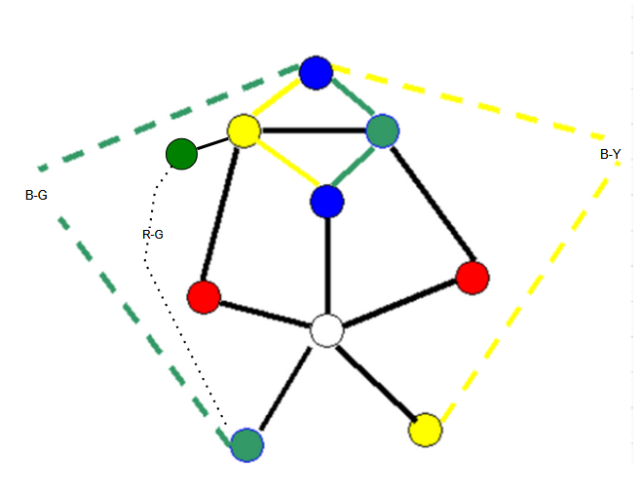

An example of the counterexample, in the graph visualizer, is shown below.
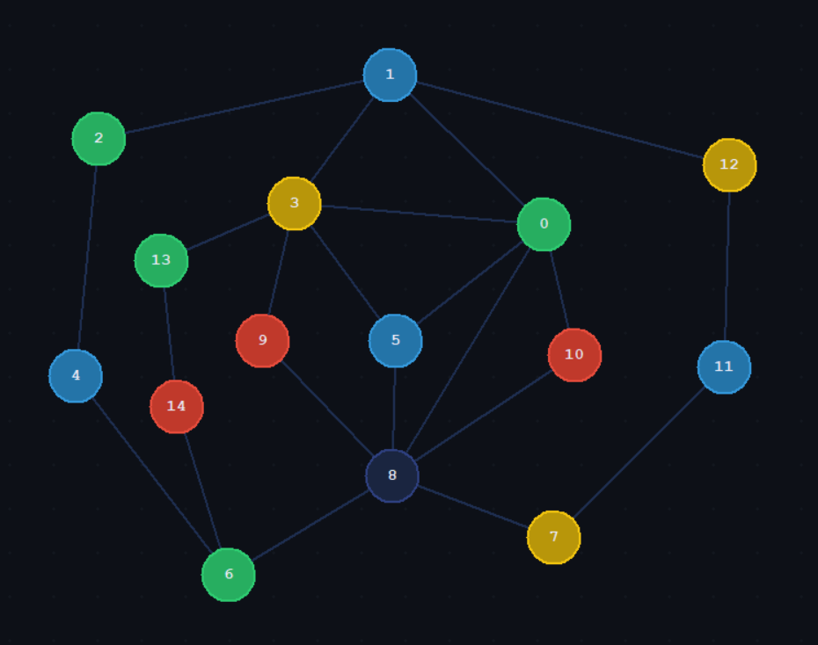
The Program produces the following output for the counterexample, nullifying the counter example, and showing that Kempe’s method can prove the 5CT.
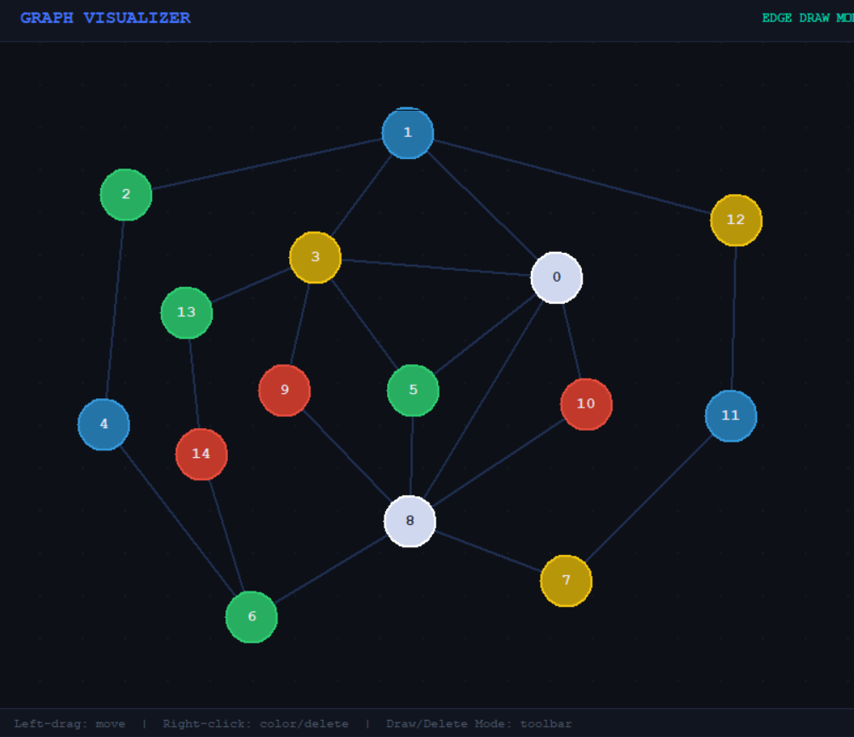

Note: having shown the counterexample to be 5 colourable above proves the 5CT because Kempe’s method is now complete; it works fully when given 5 colours. Kempe’s method works for all planar graphs since there exists a node with less than 6 neighbours in every planar graph, hence (after node colouring and deletion), Kempe’s method is complete with 5 colours assuming no other counterexamples.

- An uncoloured planar graph (map of USA, INDIA, EGYPT, UKRAINE, CHINA):
An uncoloured graph should always be 4 colourable by 4CT, our program may generate a graph with 5 colours, even if the counterexample is not encountered, due to the node removal and recolouring feature.
Map of USA (without Alaska, Hawaii for simple, connected planar graph):
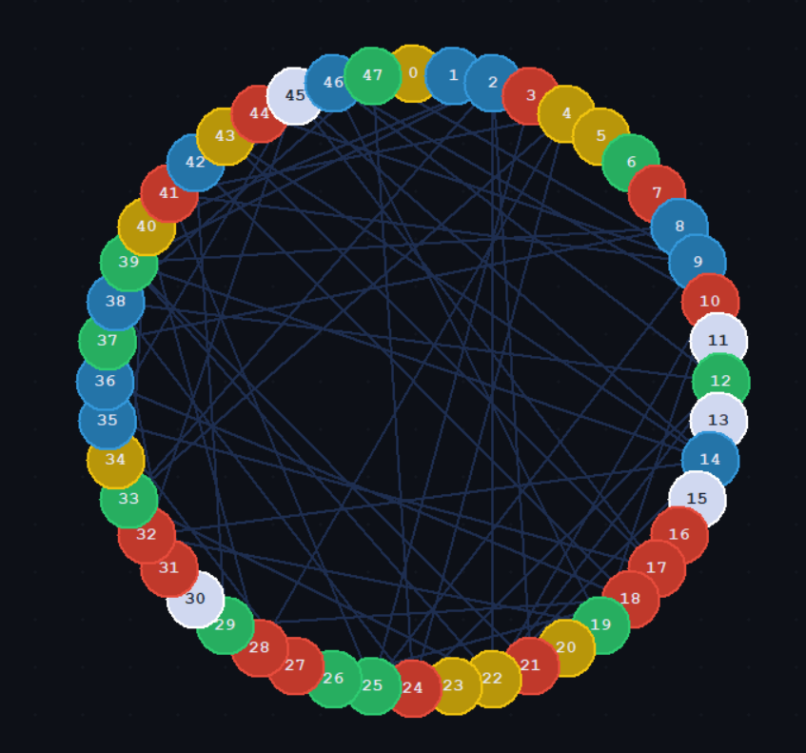

Map of India provinces (simple, unconnected planar graph):
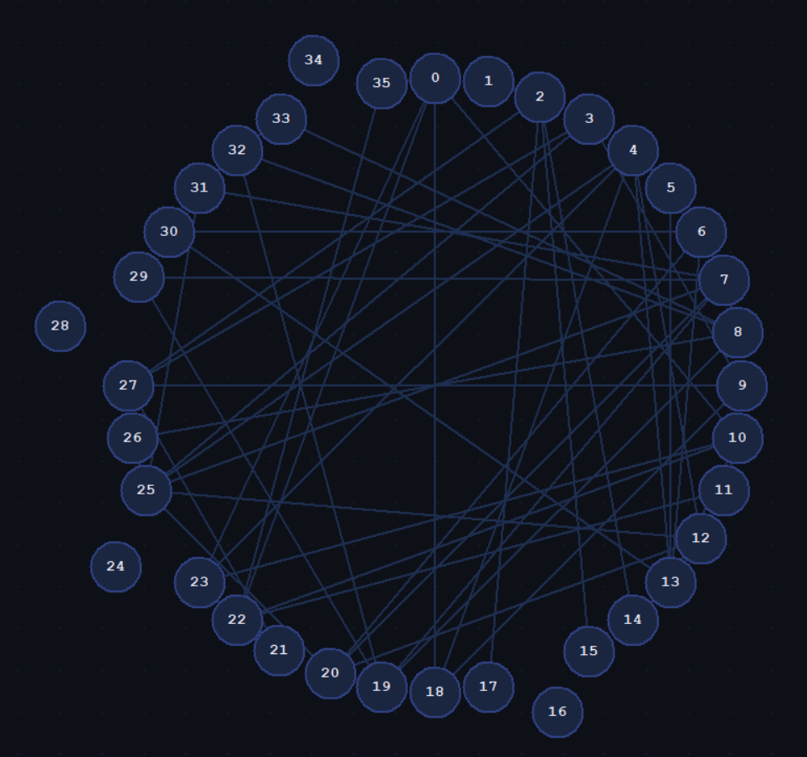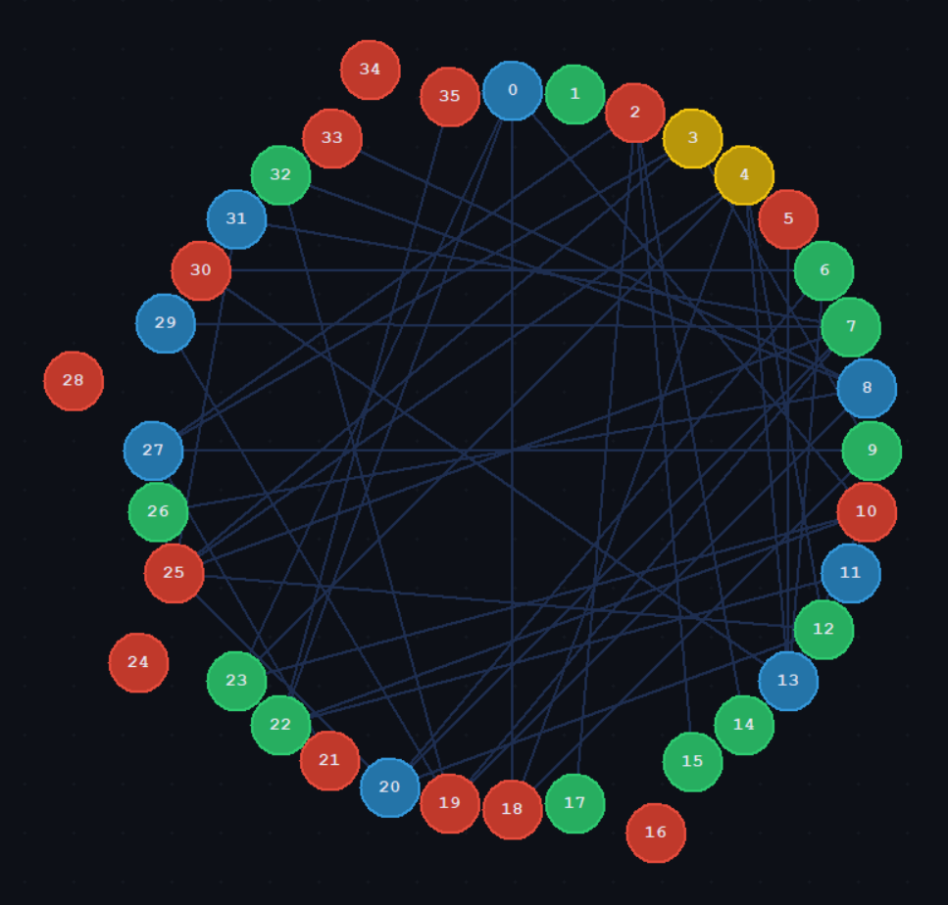
Map of ukraine ( 24 oblasts):
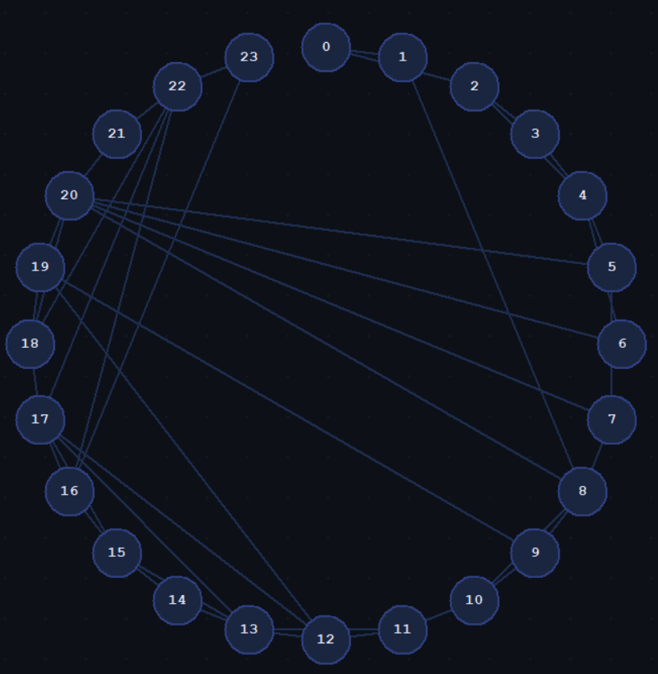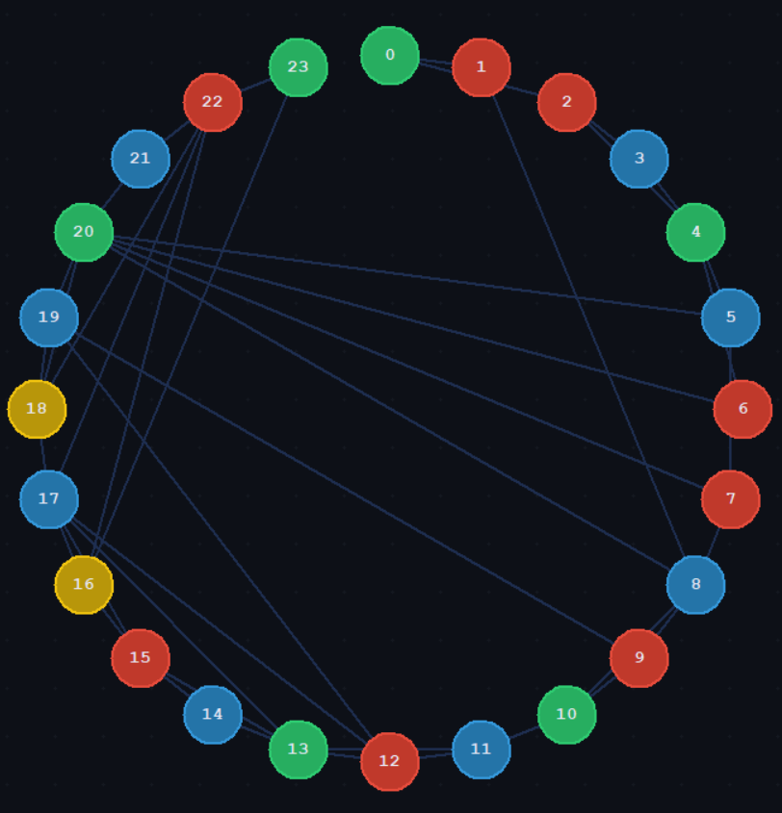
Map of Egypt (27 governorates):
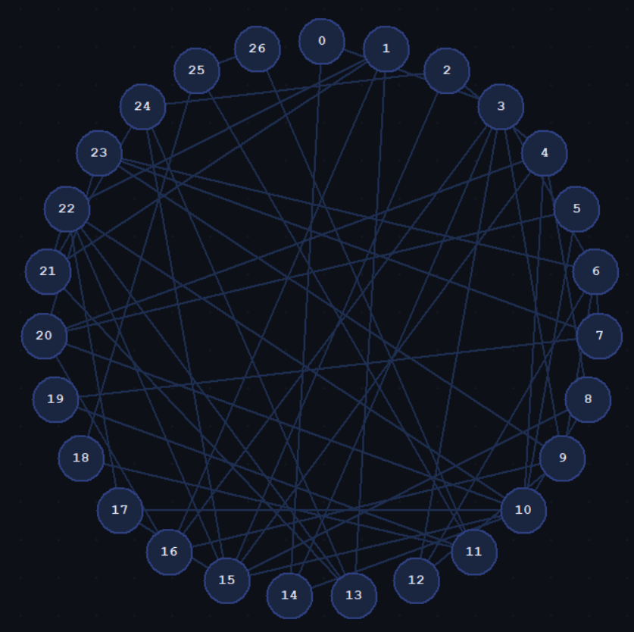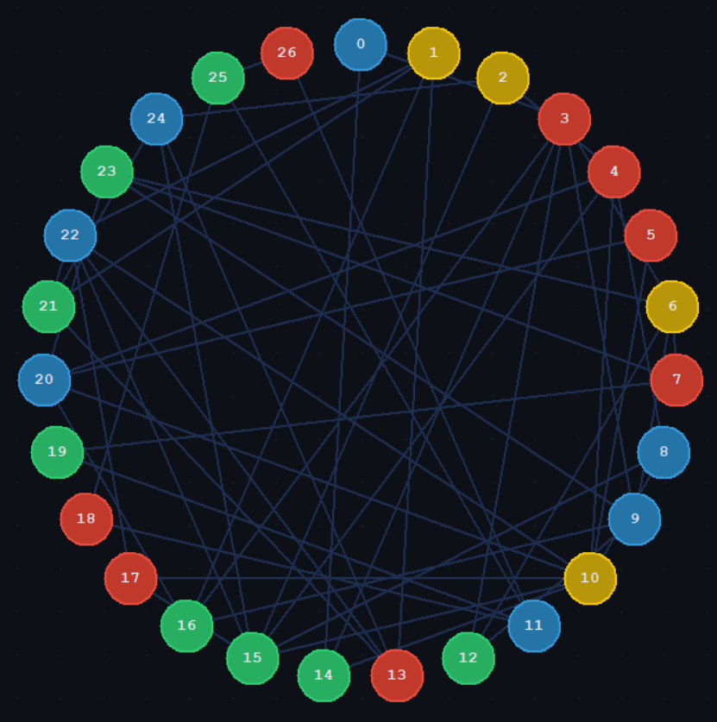
Map of China provinces:
“Not kempe-based colourable
the graph is not 5-colourable using kempe-based method”
- property * is not satisfied.

- Non-planar graphs:
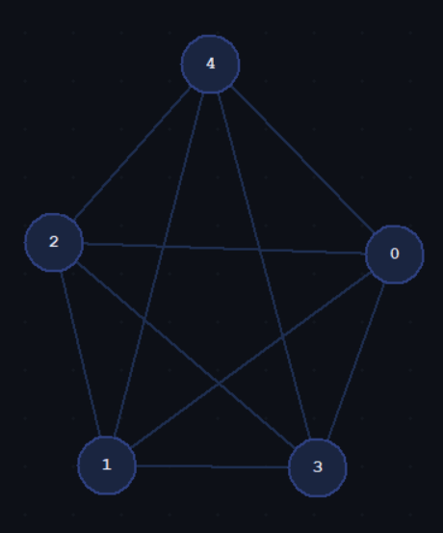
E.g. K5.
The program outputs:
“error in 4 neighbours of diff colours
Non-planar
kempe method algorithm error”

- Graphs without Property *:
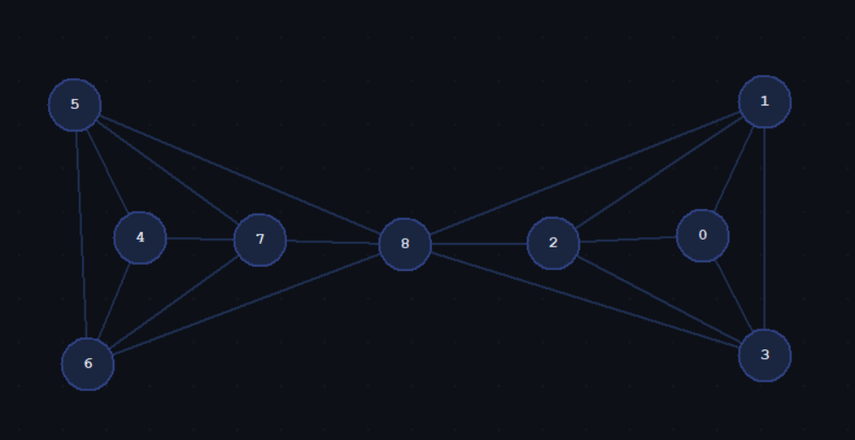
Since, property * is not held, colouring in numerical order (which the program does in ascending order), results in a deadlock when colouring node 8, the final node.
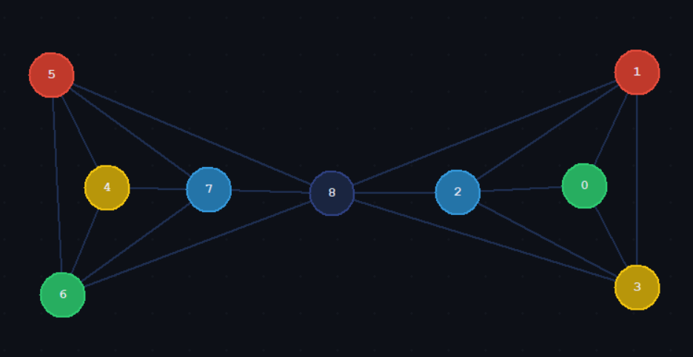
I considered developing the feature to reorganize the graph such that property * applies, but I decided to not implement this feature as the easy solution is to make sure the inputted graph has property *. Implementing this feature would take some time.
False solution: I considered a simpler solution where we consider nodes that have a coloured neighbouring node (except for the initial starting node), such that we always branch out from a least distance L, but deadlock could still occur, such as in the following counterexample (the lines rreprsente edges to coloured nodes with {R,G,B,Y}
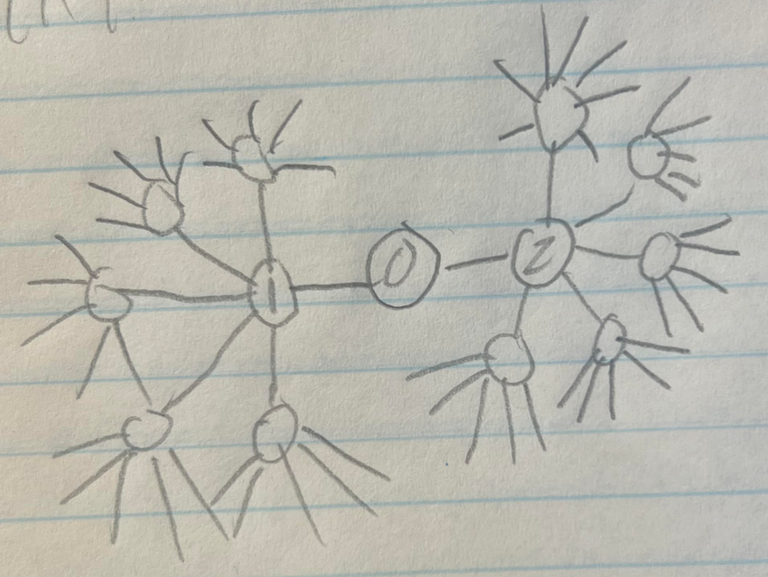

- Pre-coloured graphs:
A pre-coloured graph where there exists an uncoloured node with >5 coloured neighbours consisting of all 4 colours {R,G,B,Y} is not colourable using our program.
E.g.
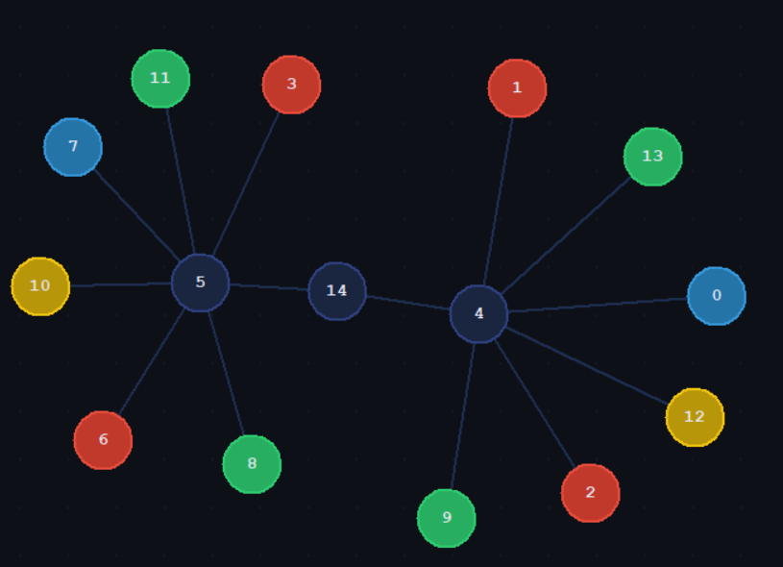

Conclusion:
An input graph must follow property *. If originally uncoloured, then the program will provide the 5-colouring of the graph. If pre-coloured, it must be coloured such that no uncoloured node has >5 coloured neighbours with entire {R, G, B, Y}, or in other words, it can be obtained naturally using the algorithm, as with the counterexample.
Next:
- Since we’re using 5-colours, we can expand the pre-coloured graph situation by incorporating the 5th colour in and possibly easing the restriction.
- Implementing the Property * feature.

Program Time Complexity:
toggleKempeChainO(V + E) ≈ O(V²)
KempeSetO(V² log V)
colourO(V²)
colourNeighboursO(V³)
deleteNodeO(V)
preProcessingO(V²)
deletedNodeErrorO(V)
main (overall)O(V⁴)

NOTES SECTION:
// What does Kempe's method even serve to achieve?

// A planar graph has a node with <6 vertices.

// What we know:
// There exists a node with less than 6 nieghbours in every graph. Let us act upon it and remove it such that we can find another
// one and guarantee it, by the equation. Everyhting right so far.
// Apply kempes method on it for a node with less than 6 neighbours. It should work since it has less than 6 coloured nieghbours
// There are some cases that don't work, the counterexample, therefore the kempes method doesn't work

// Kempe's emthod works by not delteing nodes and assuming that it it's true that by colouring a node with < 6 neighbours,
// it affects the graph such that a new node with less than 6 uncoloure dniehg bours is formed, should be true,
// Then keep on going, but there are bad cases like the counterexample, by not deleting stuff.
// This is false, since it's not ht enumbber of uncoloured nieghours, but the number of neighbours!!!

// Our 5CT method works by showing that the counterexample can be counteracted, we didn't want to show this by colouring the central
// node by memorizing when this case happens and colouring the centre black (the 5th colour) because

// Big question: so removing seems right, but why do not remove in 4CT way? do we just assume that an error happens due to the
// inevitable kempe chain and call it quits? Yes!!!!

// Now the big question is whether

//we need to choose a node with < 6 niegbours not <6 uncoloure dneighbours, since the nieghbours should b ecoloured, by
// kempes method.

// it seemed weird that the counterxample is already populated.
// but realizing it is not a predetermined colouring grah, but a graph that COULD be obtained
// from the kempe method was critical. SOme graphs simply can't be obtained.
// E.g. 5 neighbours(uncoloured) each neighbour with 6 cooured neighbours. This would brick up the system.
// Realizing that it cant ever be obtained using our method from an originally uncoloured graph was critical
// in me understanding that the roginal graph must be uncoloured. And that the counterexample
// is a version that CAN be ontained and fails. I think it CAN be obtained intuitively.
// It fails using the same method of removal, the failure is due to an inevitable kempe chain. Hence
// always failing, it can be obtained m the removal method.

// this method counteracts it and shows that all planar graphs which contain a node degree with < 6 can be 5 coloured.

// preprocessing is necessary to show that the graph can be obtained and is then solved, by the 5CT.

// original method works except for the last case (very obvious now), and it is critical to be convinced that this case
// can occur using this removal method. things that can not be obtained, can't be solved using 4CT or 5CT method shouldn't be
// considered, hence a n empty graph should be input, only graphs wchich ca n be obtained can be originally colored, but it is
// ad hoc and it should only include the counterexample as the only valid graph that has an input coloring.

// therefore, 5CT rpvoed.

//CRITICAL: ASSUME THE COUNTEREAXAPLE CAN BE OBTAINED NATURALLY USING KEMPE METHOD, WE SHOW THAT IT DOESN'T MATTER, by 5CT.
// we don't even need to show the xounterexample, assuming it can be obtained, we set our algorihtm for 5XT!!

